**Name: Qianzi Xu (Rachel)**

**CMSC110 Introduction to Computing  
Assignment#1 (Due on Tuesday, December 9, 2014)**

**Description and Thoughts**

Figure 1: Blackfish Chasing Small Fish

A sketch of a blackfish going around in circle chasing a small fish it’s never going to catch

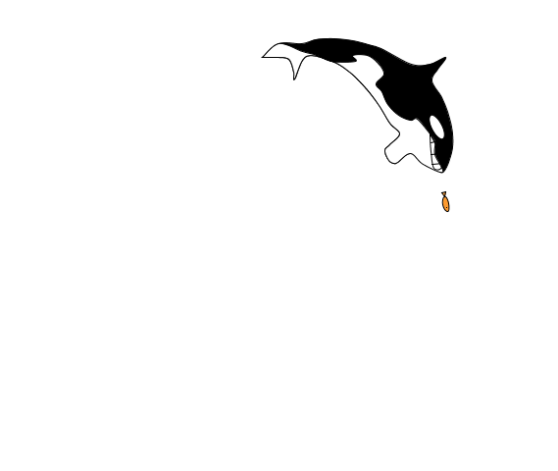

**[Insert your Image here]**

**I used rotate() function to make the blackfish go in a circle: when the angle is between (1/6)PI and (1/3)PI, the blackfish is at a lower speed and once it gets past (1/3)PI, it speeds up. The same function is used for the small fish, but it’s slightly more slowly than the blackfish during the (1/6)PI and (1/3)PI period and slightly faster during the rest of the circle, so it appears that the blackfish comes close to catching the small fish every cycle but never makes it.**

**Also, the function drawMouth() is used during the (1/6)PI-(1/3)PI period, when the blackfish is almost catching up with the small fish. DrawMouth() makes the blackfish expose its teeth (looks more like smiling though) and after the period ends, the blackfish closes its mouth again.**

**The major trouble I came across was drawing the blackfish and making the “chasing” work. For the former one I had to calculate the coordinates of a lot of points and connect them with curve, then make small adjustments to the image of the blackfish. I spent a lot of time on the latter, because when I tried to use the same “theta” for a second rotate function for the small fish, the program didn’t work. Then I realized while using the rotate() function for the second time, I need to subtract an angle from theta so that the small fish and blackfish will go at similar speeds.**